 | Department of Computer Science  Faculty of Computing  UNIVERSITI TEKNOLOGI MALAYSIA

SUBJECT NAME: | DIGITAL LOGIC
SUBJECT CODE: | SCSR1013 / SECR1013
SEMESTER: | Sem 1 – 2025 2026
LAB TITLE: | Lab 2: Combinational Digital Circuit Design Simulation Using Deeds Simulator
GROUP MEMBER: | 1. Name: _______________________________________  Matric No: _______________  2. Name: _______________________________________  Matric No: _______________
SUBMITTED DATE:

DUE DATE:

11 December 2025 ( before 11:55 pm MYT ), submit via e-learning.
MARKS:
REMARKS:
Lab # 2

Combinational Digital Circuit Design Simulation Using Deeds Simulator

A. Objectives

- To expose student with producing digital logic circuit, generating truth table and Timing Diagram with Deeds Simulator
- To expose student with a complete cycle process of a combinatorial circuit design and simulate with Deeds Simulator

B. Material

Install Deeds Software for Windows to your computer / laptop

C. Introduction

Deeds Simulator

The Digital Circuit Simulator d-DcS appears to the user as a graphical schematic editor, with a library of simplified logic components, specialized toward pedagogical needs and not describing specific commercial products.

As described before, the schematic editor allows building a simple digital networks composed of gates, flip-flops, pre-defined combinational and sequential circuits and custom-defined components (defined as Finite state machine).

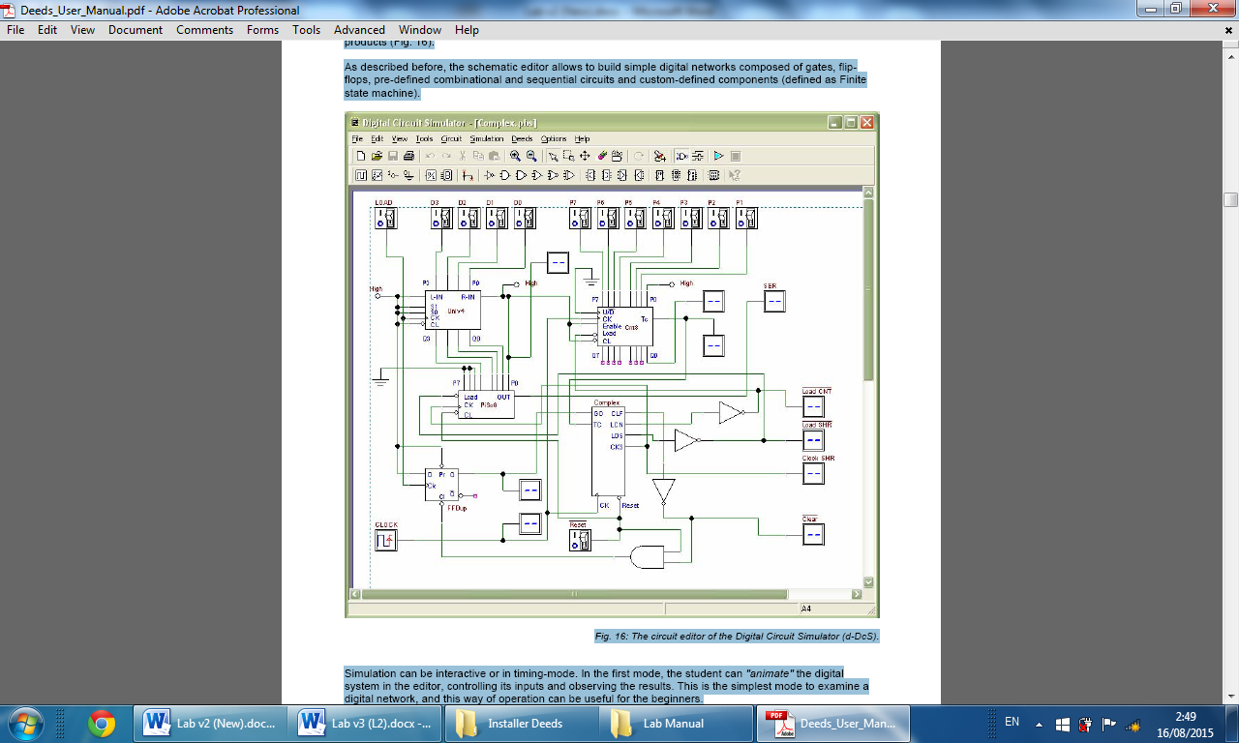

Fig. 1 Circuit Editor of Digital Circuit Simulator (d-DcS)

Simulation can be interactive or in timing-mode. In the first mode, the student can "animate" the digital system in the editor, controlling its inputs and observing the results. This is the simplest mode to examine a digital network, and this way of operation can be useful for the beginners. In the timing mode, the behavior of the circuit can be analyzed by a timing diagram window, in which the user can define graphically an input signal sequence and observe the simulation results.

Digital Circuit Simulator (d-DcS): A Simple Example

In following screen shots (Fig. 2a, 2b, and 2c), student can see the circuit during the drawing and then simulated by animation by following these simple steps:
a) student picks-up components from the bin on the Component Tool Bar.
b) connects them using Wires.
c) student activates the animation.

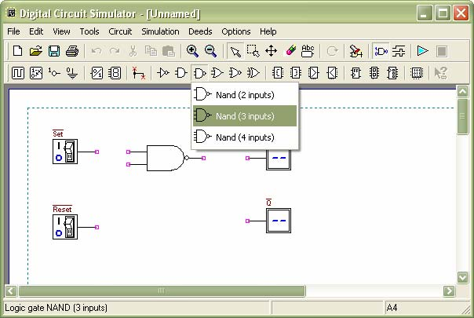

Fig. 2a Drawing Phase of the Digital Circuit Editor: Insertion of Components

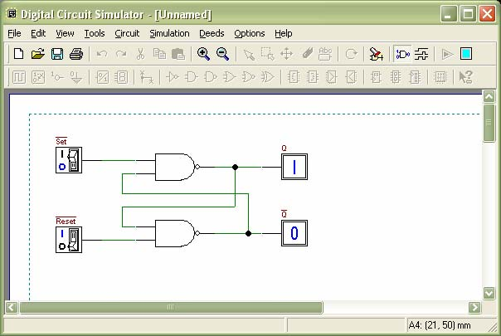

Fig. 2b Next Phase of the Work: Connection of Components using Wires

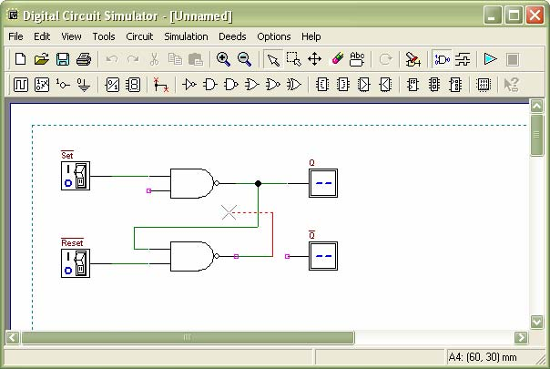

Fig. 2c Animation: User Switches Inputs and the Circuit Shows Changes on Outputs

To exit the ‘animation’ mode, it is necessary to click on the square ‘stop’ button.

Instead, if the timing simulation is to be performed, student should click on the Timing Simulation button. This will show the Timing Diagram simulation window (Fig. 3).

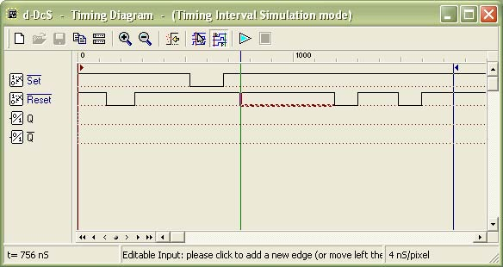

Fig. 3 Timing Diagram Simulation Window
In this window, first student should define the timing of the input signals, drawing them on the diagram with the mouse. A vertical line cursor permits to define the ‘end time’ of the simulation. When student clicks on the triangular ‘play’ button on the toolbar, the simulation is executed, and its results are displayed in the same window (Fig. 4).

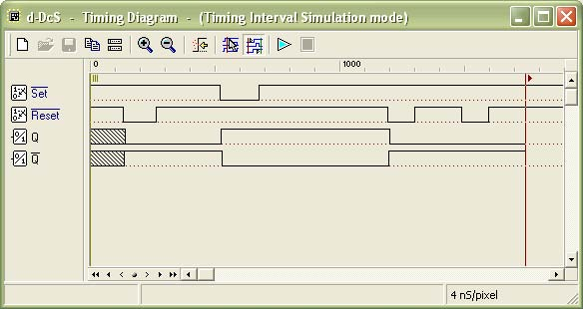
Fig. 4 Timing Simulation Results, Displayed in Timing Diagram Window

Student can verify the correct behavior of the network under test, comparing simulation results with reasoning and theory concepts.

D. Experiment

Part 1:

Refer to circuit in Figure 1 below:

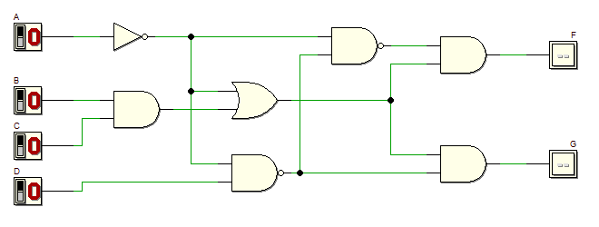
Figure 1

a) Refer to the above circuit. Derive Boolean expression for output F and G.

b) Simplify the equation output F using laws, rules and De Morgan Theorem, and write the equation in Sum of Product (SOP).

c) Simplify equation output G using laws, rules and De Morgan Theorem, and write the equation in Product of Sum (POS).

c) Simulate the circuit and construct the truth table and complete the following.

Truth table for output circuit F and G shown in Figure 1

Input |  |  |  | Output
A | B | C | D | F | G
0 | 0 | 0 | 0
0 | 0 | 0 | 1
0 | 0 | 1 | 0
0 | 0 | 1 | 1
0 | 1 | 0 | 0
0 | 1 | 0 | 1
0 | 1 | 1 | 0
0 | 1 | 1 | 1
1 | 0 | 0 | 0
1 | 0 | 0 | 1
1 | 0 | 1 | 0
1 | 0 | 1 | 1
1 | 1 | 0 | 0
1 | 1 | 0 | 1
1 | 1 | 1 | 0
1 | 1 | 1 | 1
d) Using Deeds, draw circuit as shown in previous Figure 1. Simulate and complete the waveform output F and G by referring the following diagram:

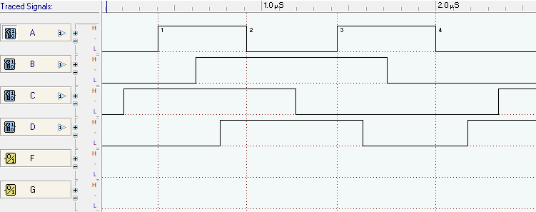

Answer

Copy and paste your timing diagram in Deeds below:

e) Write Boolean equation for output F using Sigma notation.

f) Write Boolean equation for output G using Pi notation.

Part 2:

Combinational circuit design process and simulate with Deeds Simulator

Design Process

- Determine Parameter Input / Output and their relations
- Construct Truth Table
- Using K-Map, get the SOP optimized form of all Boolean equation outputs
- Draw the circuit and use duality symbol; convert AND-OR circuit to NAND gates ONLY.
- Simulate the design using Deeds Simulator. Check the results according to Truth Table and Timing Diagram Operation.

Problem Description

Using universal gate NAND gates only, design a logic circuit that controls an LRT coach door OPEN operation at 3 LRT Stations: Pandan (S1), Pudu (S2) and Maluri (S3).
Consider the following inputs:

  - LRT coach moving status (S)
    - S = bit 1 indicates the coach has stopped.
    - S = bit 0 indicates the coach is moving.

  - Sensor location at Station S1, S2, and S3
    - HIGH indicates the LRT coach has arrived at the particular station. For instance, S1 = 1 indicates LRT coach has arrived at station S1, and sensor S2=S3=0.
    - It is IMPOSSIBLE for the LRT coach to arrive at more than one station at one time.

The circuit outputs are the OPEN and ALARM signal
  - OPEN = bit 1 indicates the coach door will be opened
  - ALARM =bit 1 indicates the alarm is activated

The following are the conditions for OPEN and ALARM outputs at Station S1, S2, and S3
  - The door will be opened ONLY IF the coach stopped at any ONE of the stations.
  - The alarm will be activated:
    - If the coach arrives at any station and it does not stop. or
    - If the coach stopped but NOT at stations S1, S2 or S3.
Experimental steps

- Complete the Truth Table in Table 1 below for the LRT operations. Use variables S, S1, S2, and S3 as INPUTS and OPEN and ALARM as OUTPUTS.
Table 1
INPUT |  |  |  | OUTPUT
S | S1 | S2 | S3 | OPEN | ALARM
0 | 0 | 0 | 0
0 | 0 | 0 | 1
0 | 0 | 1 | 0
0 | 0 | 1 | 1
0 | 1 | 0 | 0
0 | 1 | 0 | 1
0 | 1 | 1 | 0
0 | 1 | 1 | 1
1 | 0 | 0 | 0
1 | 0 | 0 | 1
1 | 0 | 1 | 0
1 | 0 | 1 | 1
1 | 1 | 0 | 0
1 | 1 | 0 | 1
1 | 1 | 1 | 0
1 | 1 | 1 | 1

- Use K-Map to get optimized SOP Boolean equations for the OPEN and ALARM circuits.

- From equations in (ii), draw your final OPEN and ALARM circuits using Deeds Simulator. Paste your circuit diagram below:

- Simulate the circuit design in (iii) and construct Truth Table in Table 2.

Table 2
INPUT |  |  |  | OUTPUT
S | S1 | S2 | S3 | OPEN | ALARM
0 | 0 | 0 | 0
0 | 0 | 0 | 1
0 | 0 | 1 | 0
0 | 0 | 1 | 1
0 | 1 | 0 | 0
0 | 1 | 0 | 1
0 | 1 | 1 | 0
0 | 1 | 1 | 1
1 | 0 | 0 | 0
1 | 0 | 0 | 1
1 | 0 | 1 | 0
1 | 0 | 1 | 1
1 | 1 | 0 | 0
1 | 1 | 0 | 1
1 | 1 | 1 | 0
1 | 1 | 1 | 1

Compare the answer of Table 2 and Table 1. What is your conclusion?

_______________________________________________________________________

_______________________________________________________________________

_______________________________________________________________________

_______________________________________________________________________

- Use dual symbol to convert, AND-OR circuit to NAND gates only. Draw the final circuit using Deeds Simulator. Paste your circuit diagram below:

`

- Simulate the final NAND gates design in (v) and construct Truth Table in Table 3.

Table 3
INPUT |  |  |  | OUTPUT
S | S1 | S2 | S3 | OPEN | ALARM
0 | 0 | 0 | 0
0 | 0 | 0 | 1
0 | 0 | 1 | 0
0 | 0 | 1 | 1
0 | 1 | 0 | 0
0 | 1 | 0 | 1
0 | 1 | 1 | 0
0 | 1 | 1 | 1
1 | 0 | 0 | 0
1 | 0 | 0 | 1
1 | 0 | 1 | 0
1 | 0 | 1 | 1
1 | 1 | 0 | 0
1 | 1 | 0 | 1
1 | 1 | 1 | 0
1 | 1 | 1 | 1

Compare the answer of Table 2 and Table 3. What is your conclusion?

______________________________________________________________________

______________________________________________________________________

______________________________________________________________________

 | Fully  Completed |  | Partially Completed |  | Checked by: __________

